**Cook Book**

**Ideation Phase**

**Define the Problem Statements**

|  |  |
| --- | --- |
| Date | 06 March 2025 |
| Team ID | SWTID1741338224146158 |
| Project Name | Cook Book |
| Maximum Marks | 2 Marks |

**Customer Problem Statement Template:**

Create a problem statement to understand your customer's point of view. The Customer Problem Statement template helps you focus on what matters to create experiences people will love.

A well-articulated customer problem statement allows you and your team to find the ideal solution for the challenges your customers face. Throughout the process, you’ll also be able to empathize with your customers, which helps you better understand how they perceive your product or service.

Reference: <https://miro.com/templates/customer-problem-statement/>

**Example:**

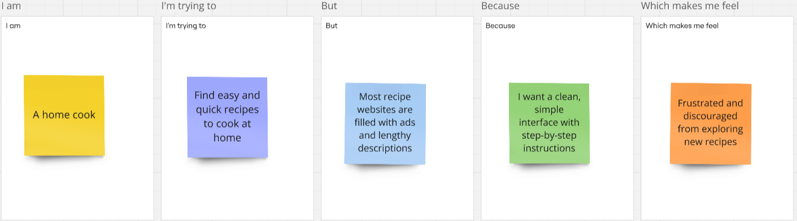

|  |  |  |  |  |  |
| --- | --- | --- | --- | --- | --- |
| Problem Statement (PS) | I am (Customer) | I’m trying to | But | Because | Which makes me feel |
| PS-1 | A home cook | Find easy and quick recipes to cook at home | Most recipe websites are filled with ads and lengthy descriptions | I want a clean, simple interface with step-by-step instructions | Frustrated and discouraged from exploring new recipes |
| PS-2 | A beginner in cooking | Learn how to cook different meals | Many recipe platforms assume prior knowledge | I need clear instructions, ingredient measurements, and cooking tips | Overwhelmed and unsure about trying new recipes |
| PS-3 | A health-conscious user | Discover healthy recipes based on my diet | Most apps don’t filter recipes based on dietary needs | I need an easy way to find recipes that fit my preferences (e.g., vegan, keto) | Limited in my choices and frustrated with manual searching |
| PS-4 | A busy professional | Plan meals for the week efficiently | Many apps don’t offer meal planning features | I need a way to save and organize recipes for quick access | Disorganized and unsure about what to cook daily |